Assignment SQL

1. Start by casting the value “24.423423” to a float value.

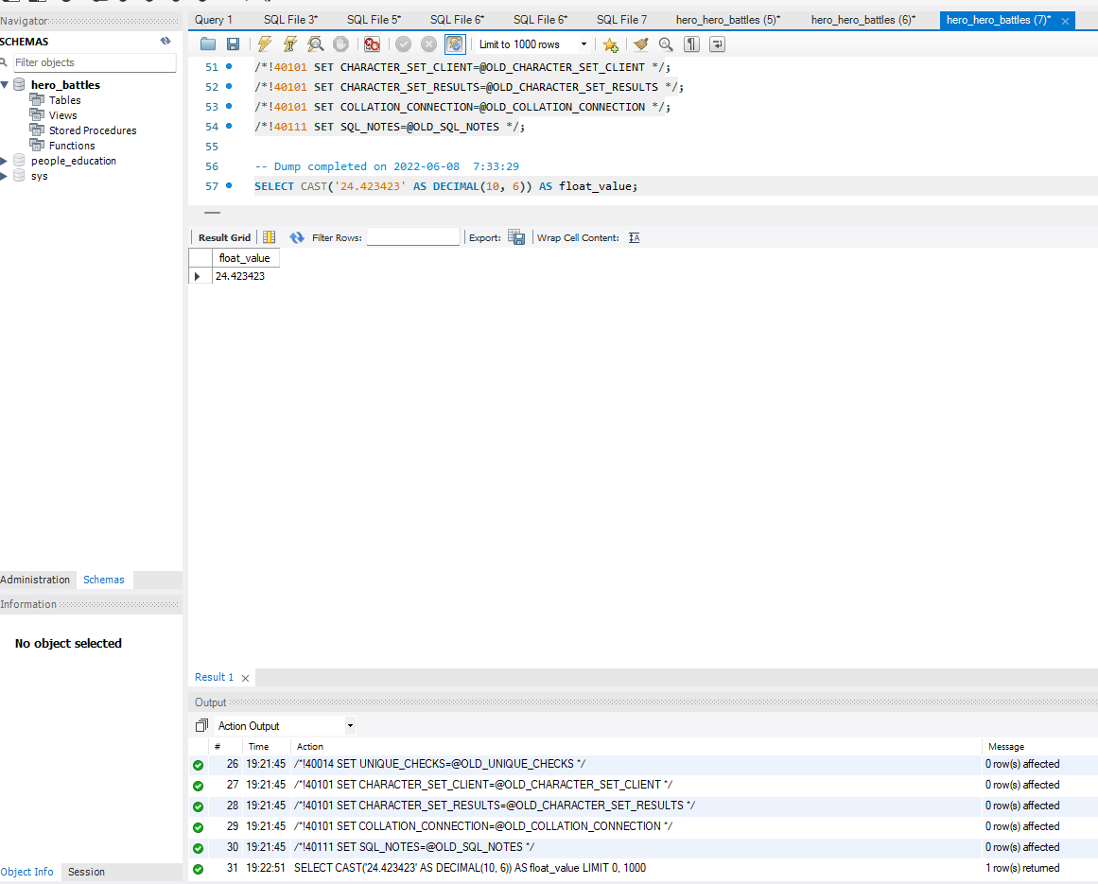

2 return the date, time, hour, month, second, and minute data for the hero_battles table based off of the date column.

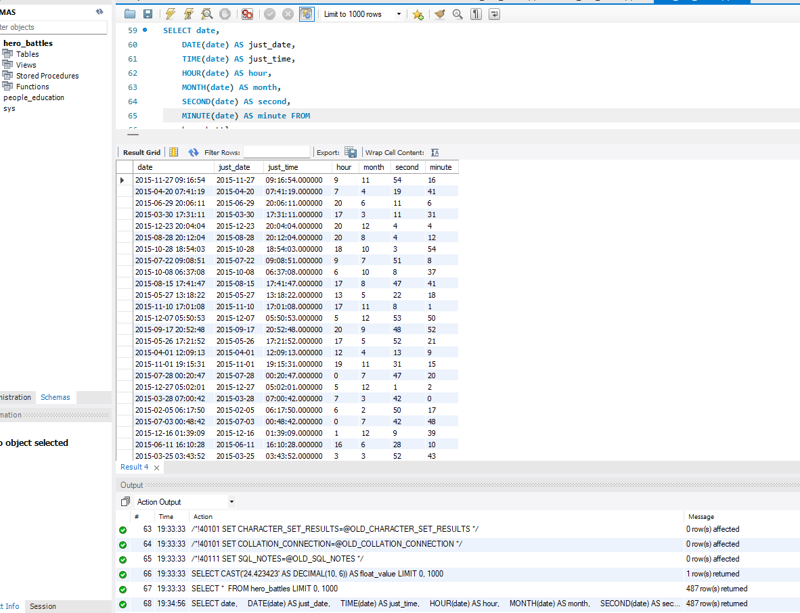

3 Create a histogram for the number of enemies fought. No need to round

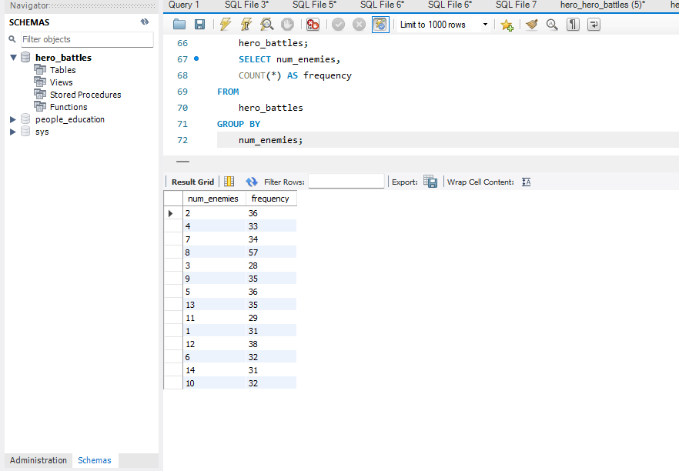

4Write a query to replace all of the occurrences of Batman with Batwoman. Return only the name column

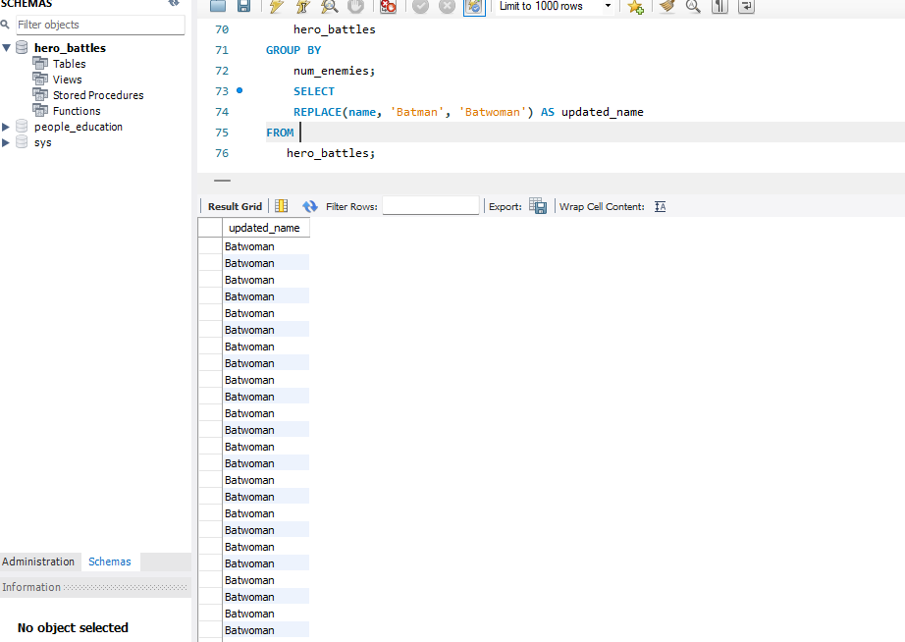

5 Make a new query that creates a sentence that says, “This battle occurred at 14 o’clock,” but replace 14 with the hour of that particular battle.

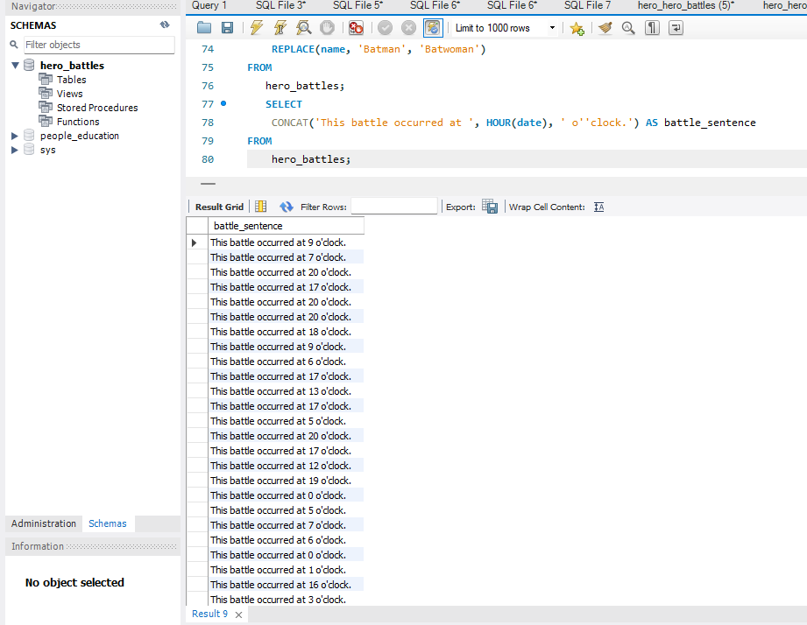

6 Create a query that makes a sentence describing each superhero. State their name, and state what comic series they are from. For example, “James Bond is from Titan Books.” Use the heroes_information table and the name and publisher columns.

SELECT CONCAT(name, ' is from ', publisher, '.') AS superhero_description

FROM heroes_information;